UI Path set Up

Click new process

Manage packages

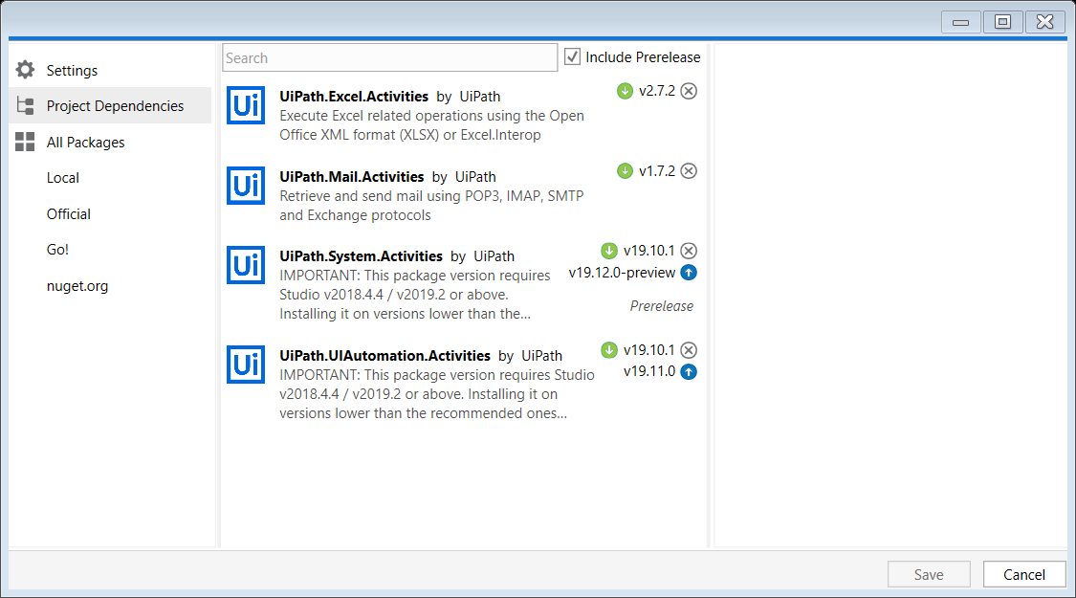

Create new sequence – series of steps to perform the activity

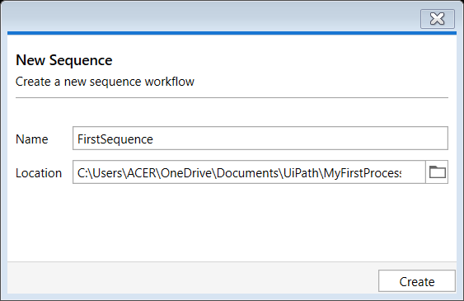

Within sequence we can add any number of activities

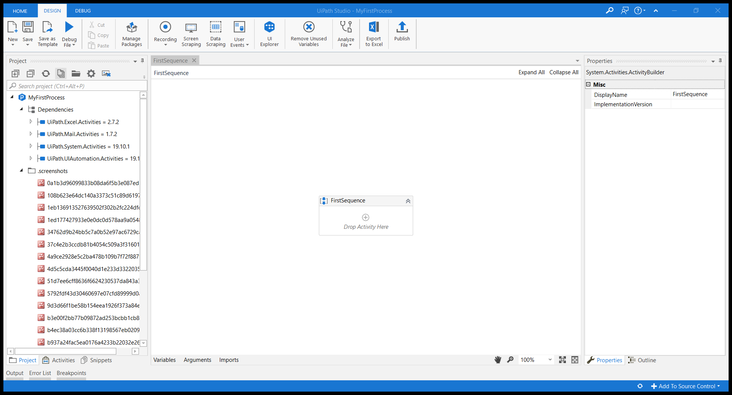

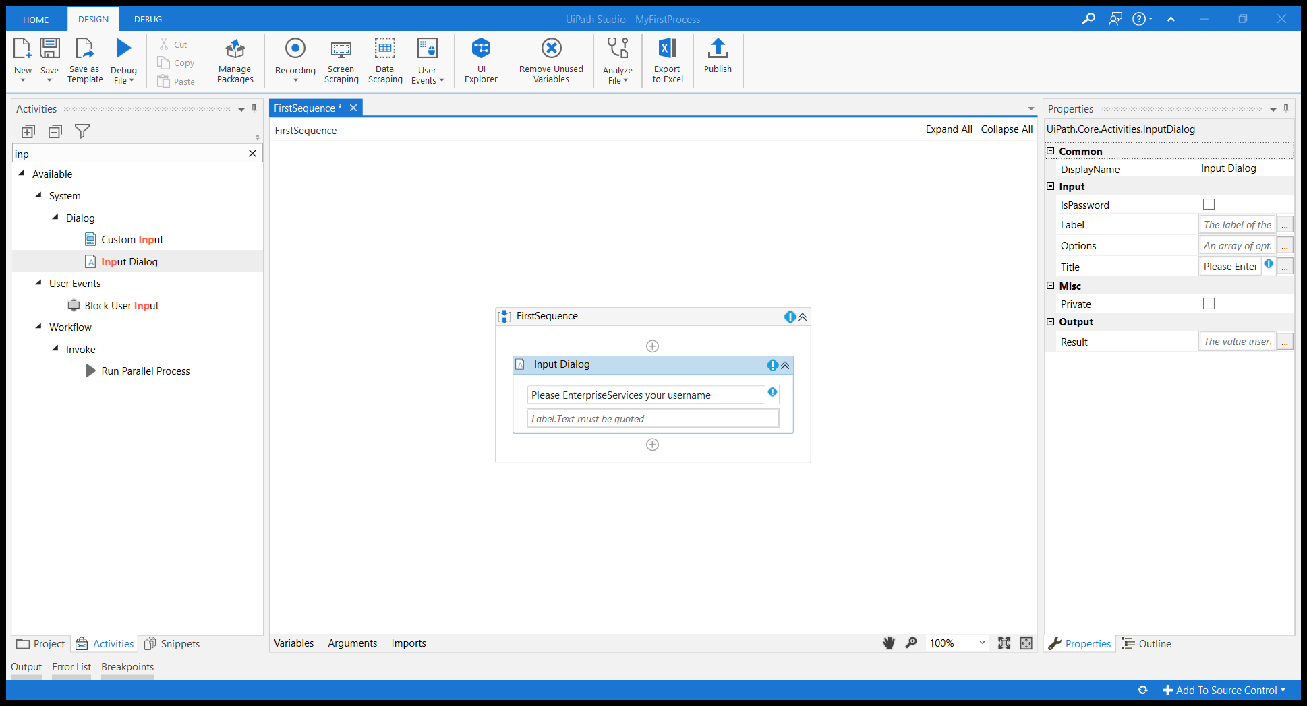

Input label activity

Create a variable

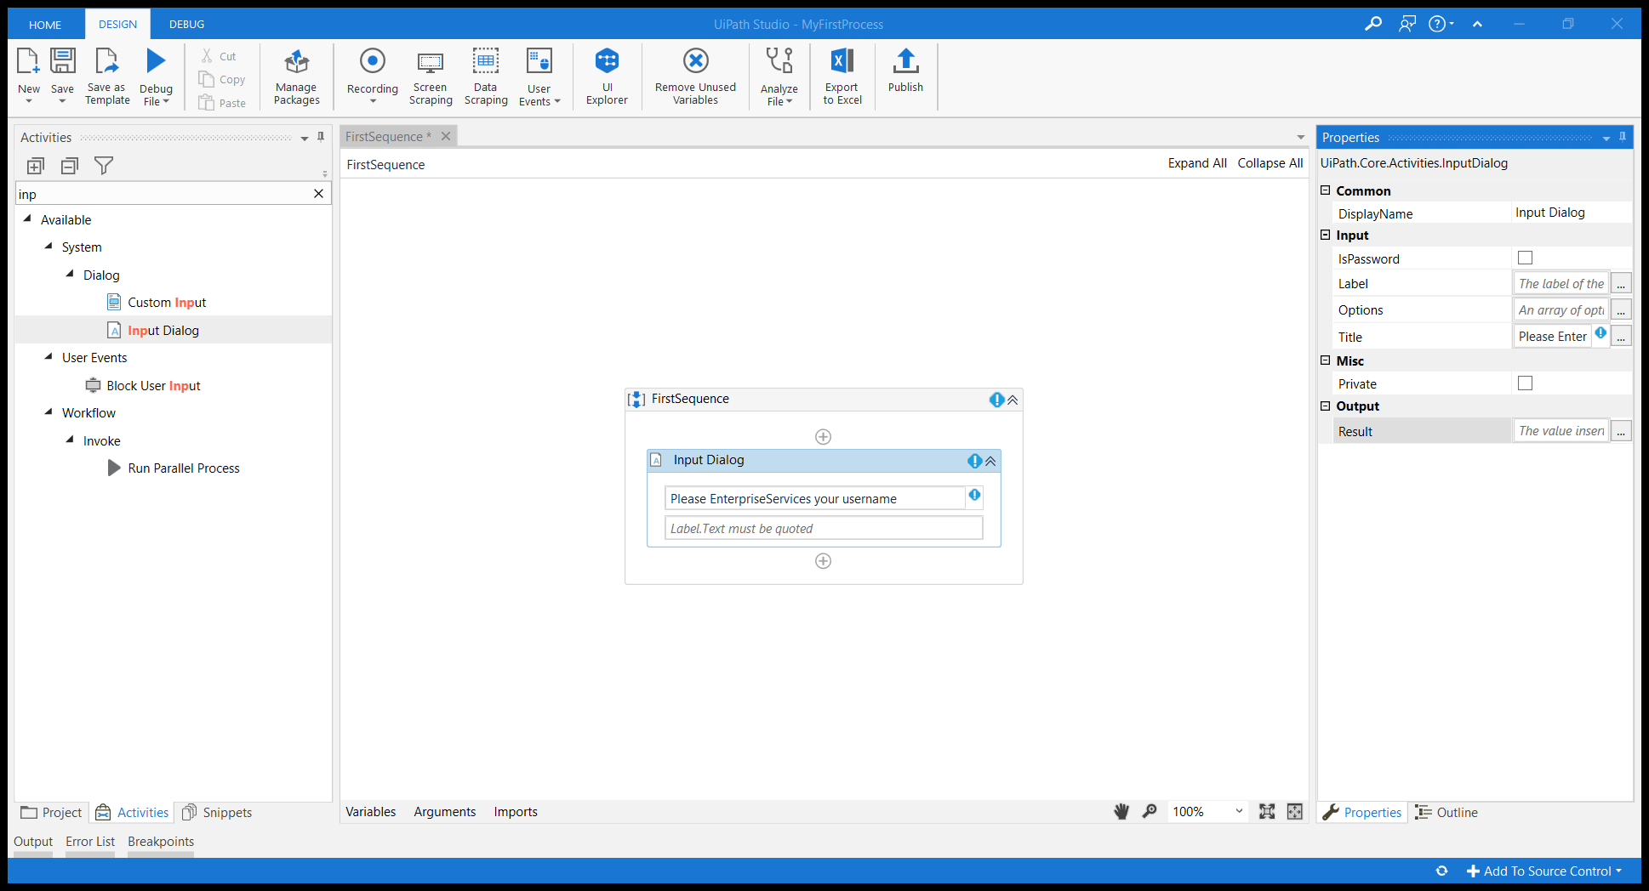

Ctrl+k – result tab in the properties section

Variable created

Create another activity

Message box

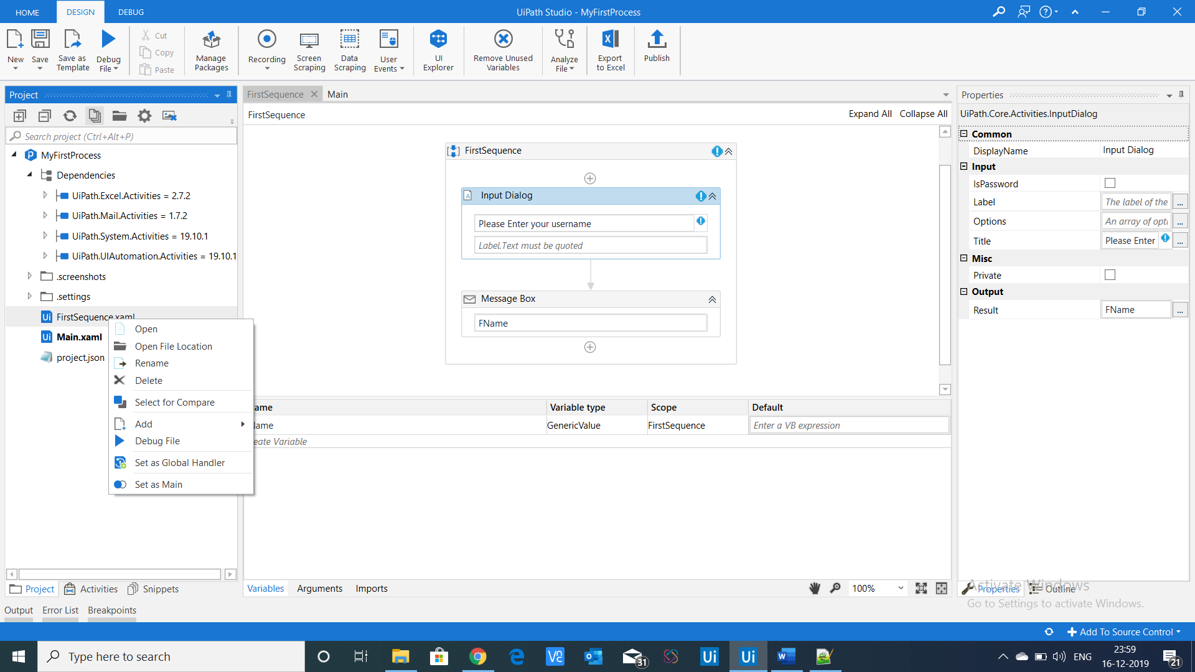

Set the sequence as main sequence

Compilation error

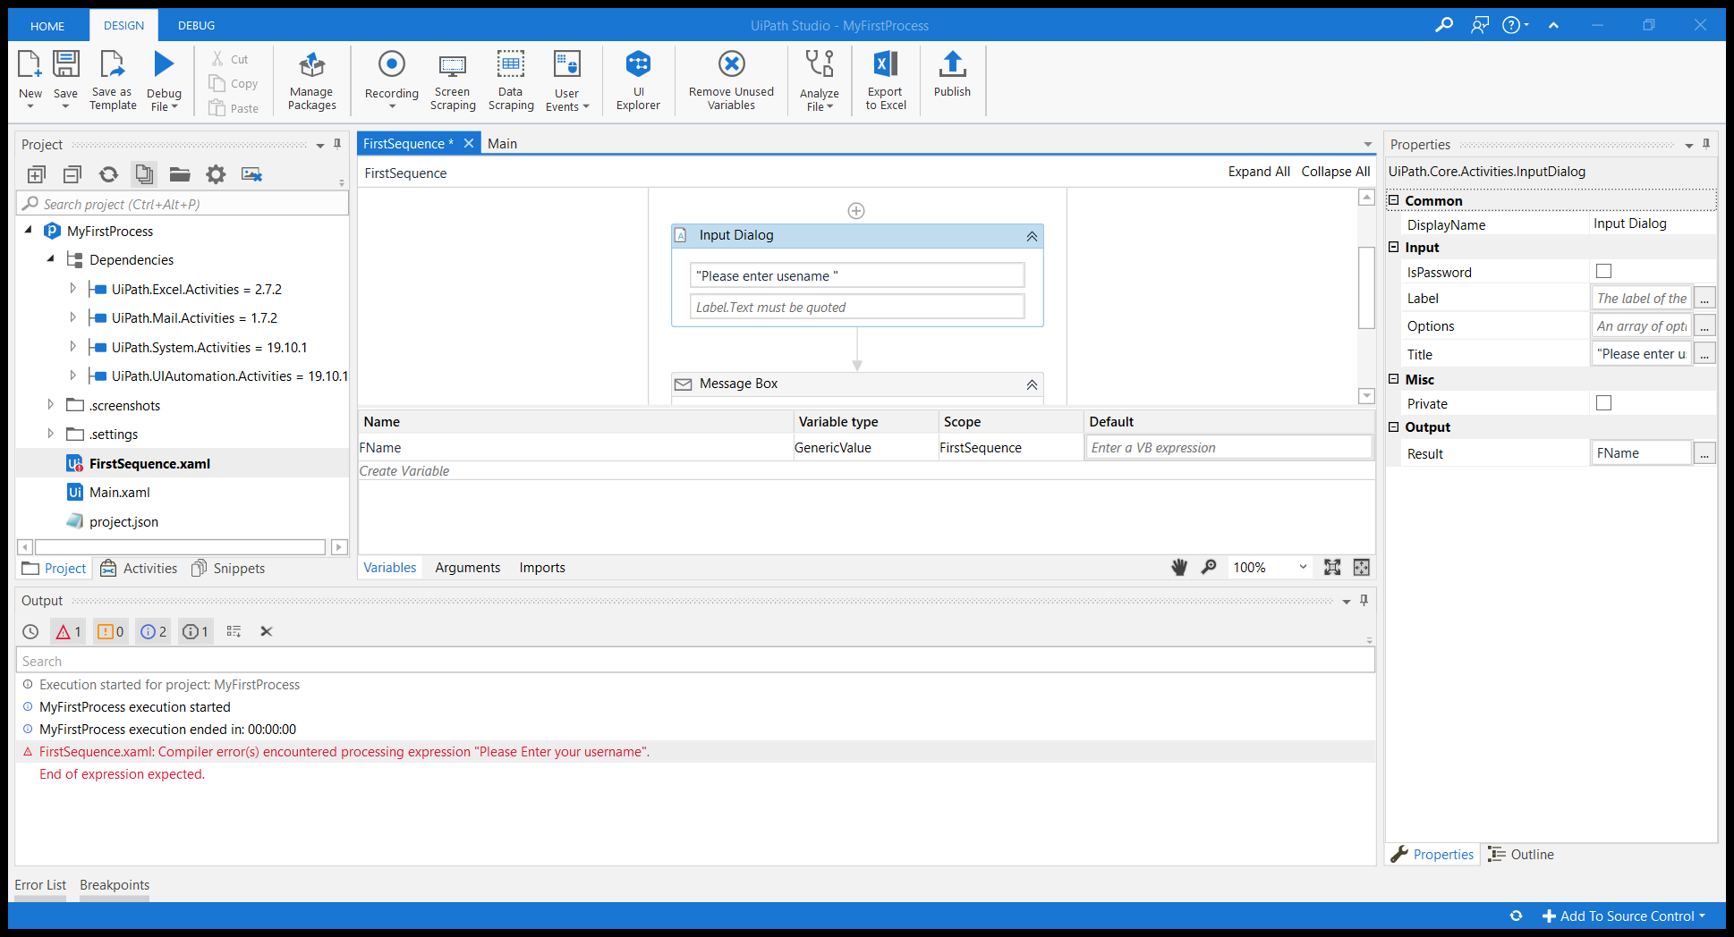

Create new sequence

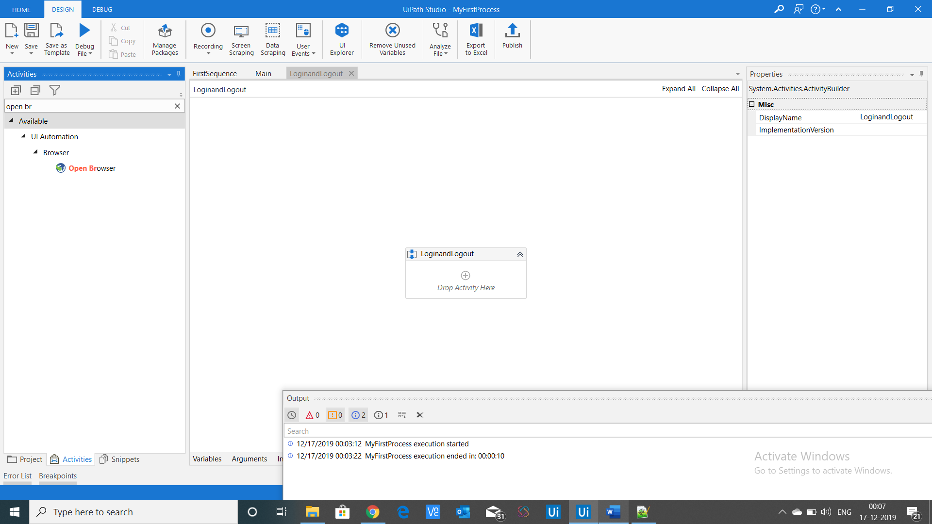

Give browser url

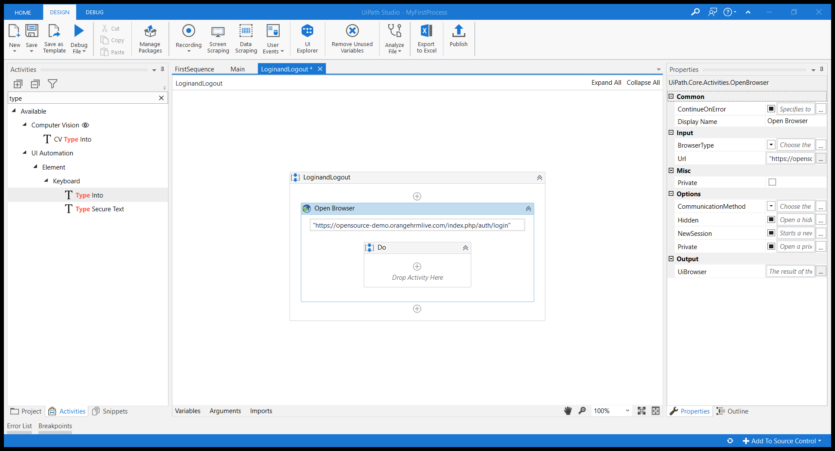

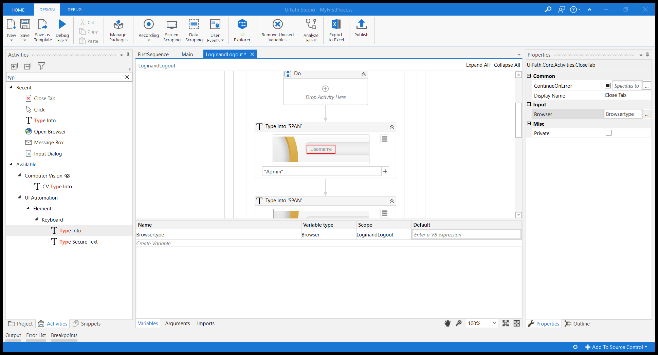

Type edit box

Click

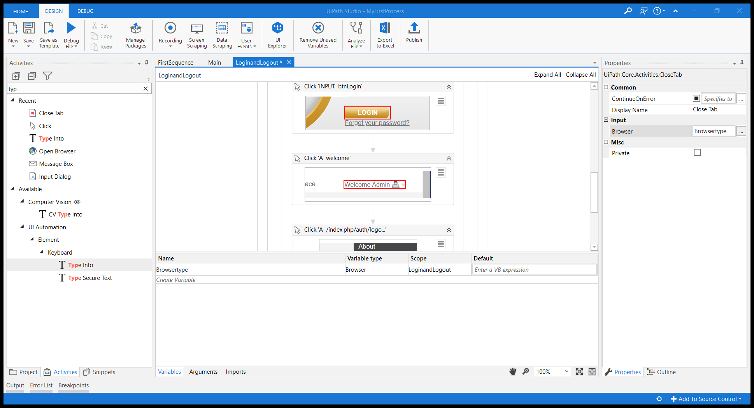

Create browser variable and select type of browser

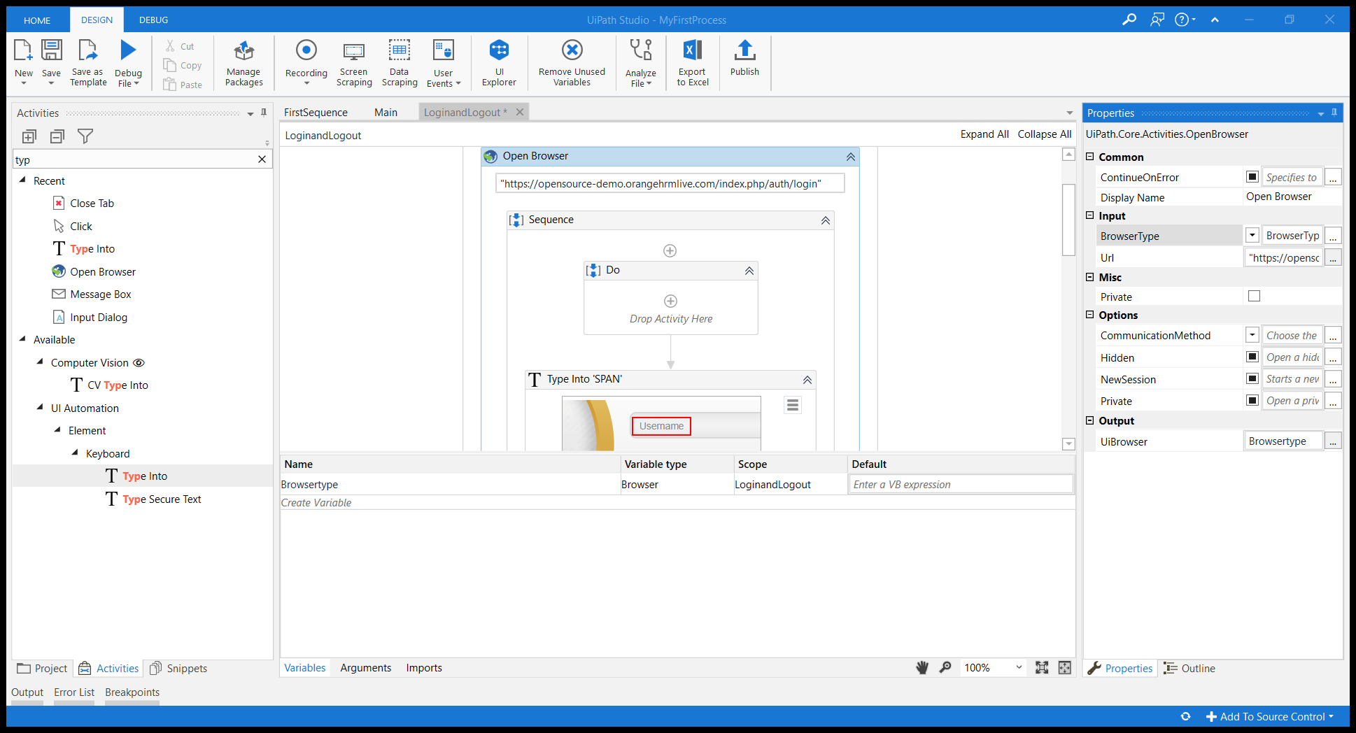

Outline

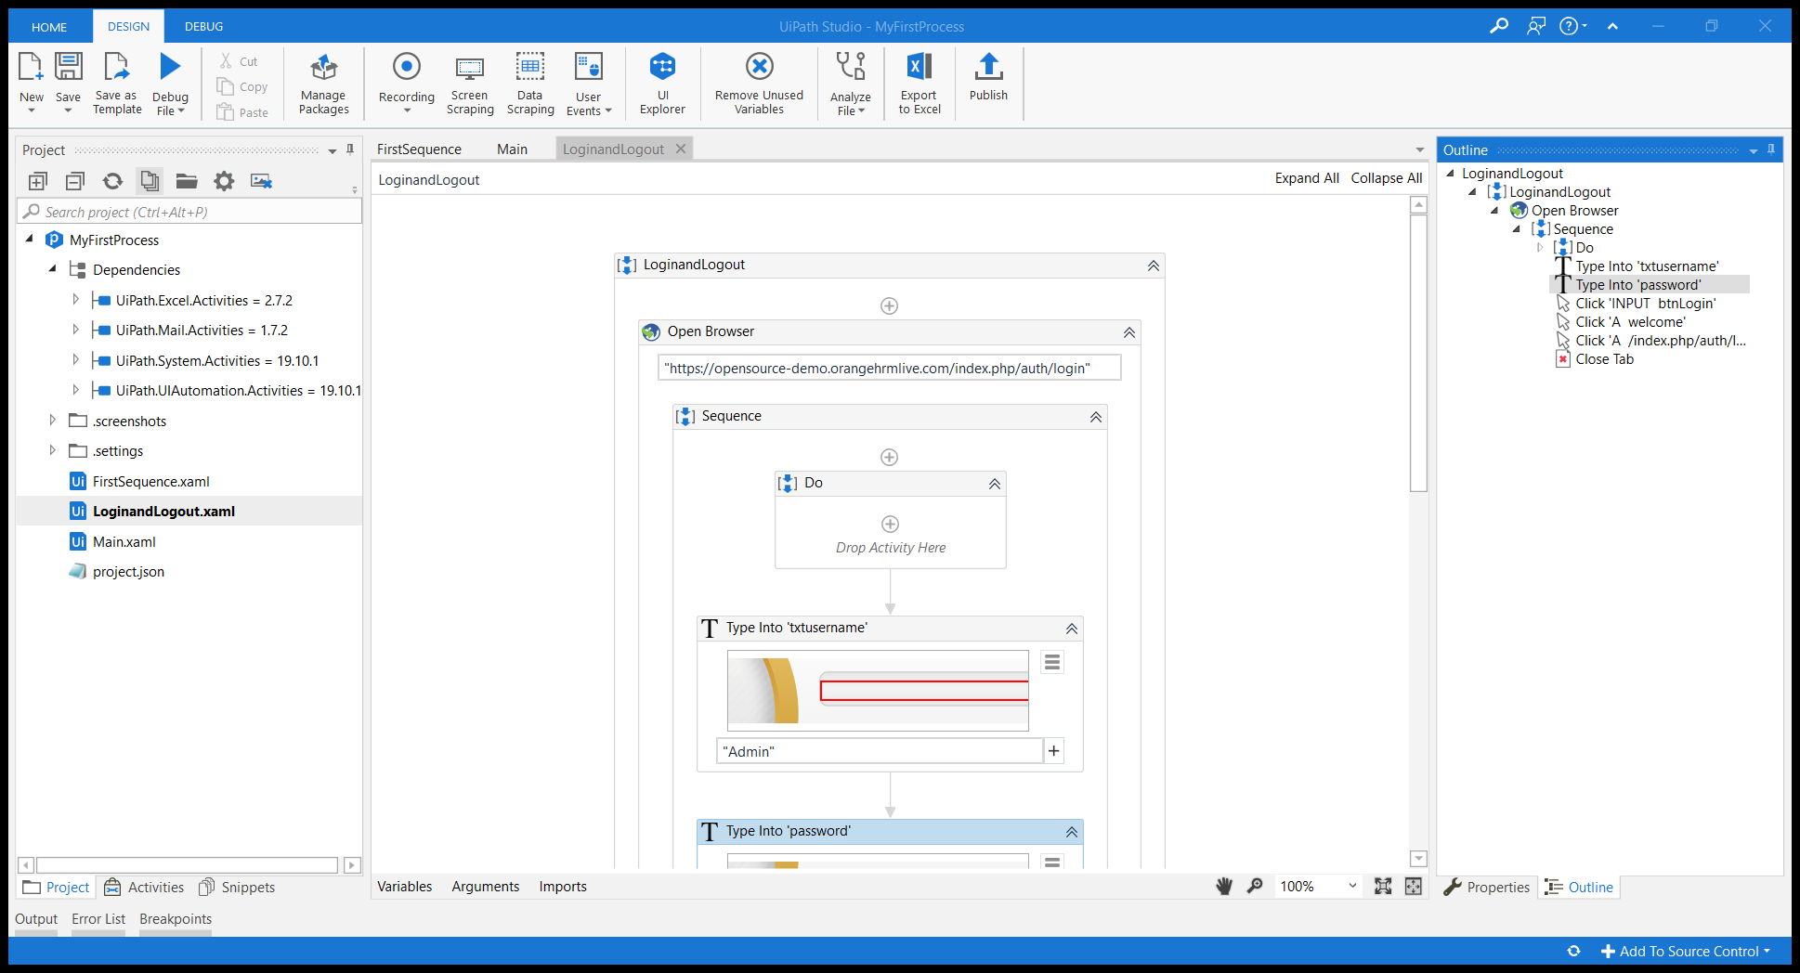

Edit properties

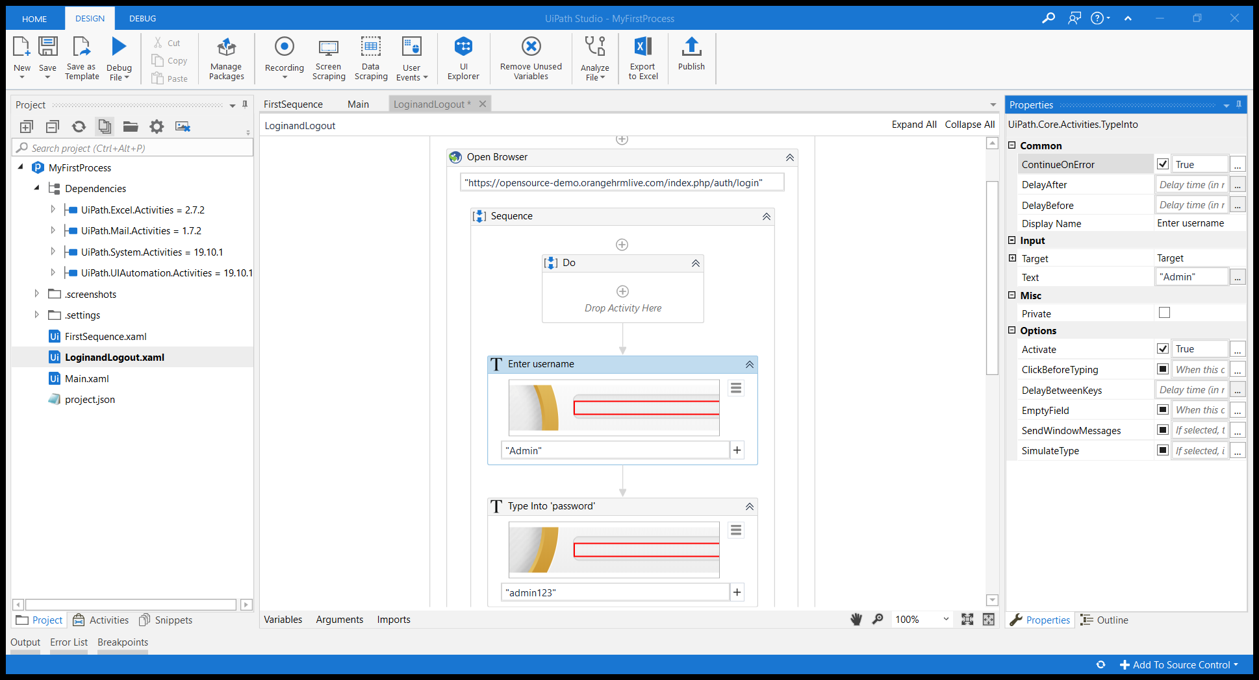

Highlight element

Automate the desktop application